**Chapter 2**

**Vectors in Space**

**2.4 The Cross Product**

**Section Exercises**

**For the following exercises, the vectors  and  are given.**

1. **Find the cross product of the vectors  and  Express the answer in component form.**
2. **Sketch the vectors  and **

183.  

Answer: a. 

b.

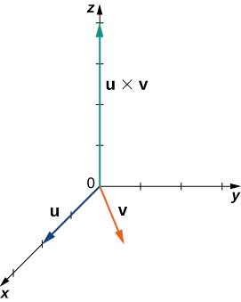

184.  

Answer: a. 

b.

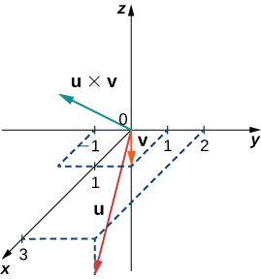

185. , 

Answer: a. 

b.

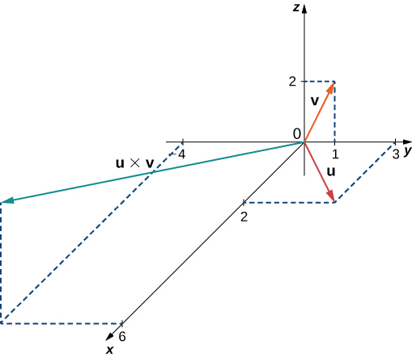

186. , 

Answer: a. 

b.

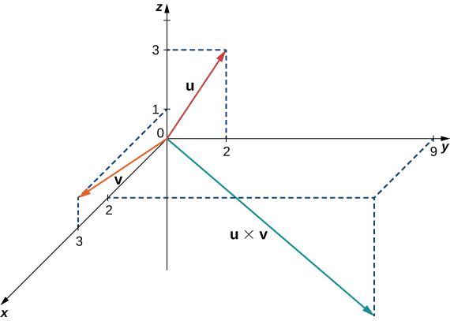

187. Simplify 

Answer: 

188. Simplify 

Answer: 

**In the following exercises, vectors  and  are given. Find unit vector  in the direction of the cross product vector  Express your answer using standard unit vectors.**

189.  

Answer:

190.  

Answer: 

191.   where   and 

Answer: 

192.   where  and 

Answer: 

193. Determine the real number  such that  and  are orthogonal, where  and 

Answer: 

194. Show that  and cannot be orthogonal for any  real number, where  and 

Answer: This is a proof; therefore, no answer is provided.

195. Show that  is orthogonal to  and  where  and  are nonzero vectors.

Answer: This is a proof; therefore, no answer is provided.

196. Show that  is orthogonal to  where  and  are nonzero vectors.

Answer: This is a proof; therefore, no answer is provided.

197. Calculate the determinant 

Answer: 

198. Calculate the determinant 

Answer: 

**For the following exercises, the vectors  and  are given. Use determinant notation to find vector  orthogonal to vectors  and **

199.   where  is a real number

Answer: 

200.   where  is a nonzero real number

Answer: 

201. Find vector  where   and 

Answer: 

202. Find vector  where   and 

Answer: 

203. **[T]** Use the cross product  to find the acute angle between vectors  and  where  and  Express the answer in degrees rounded to the nearest integer.

Answer: 

204. **[T]** Use the cross product  to find the obtuse angle between vectors  and  where  and  Express the answer in degrees rounded to the nearest integer.

Answer: 

205. Use the sine and cosine of the angle between two nonzero vectors  and  to prove Lagrange’s identity: 

Answer: This is a proof; therefore, no answer is provided.

206. Verify Lagrange’s identity  for vectors  and 

Answer: This is a proof; therefore, no answer is provided.

207. Nonzero vectors  and  are called *collinear* if there exists a nonzero scalar  such that  Show that  and  are collinear if and only if 

Answer: This is a proof; therefore, no answer is provided.

208. Nonzero vectors  and  are called *collinear* if there exists a nonzero scalar  such that  Show that vectors  and  are collinear, where   and 

Answer: This is a proof; therefore, no answer is provided.

209. Find the area of the parallelogram with adjacent sides  and 

Answer:

210. Find the area of the parallelogram with adjacent sides  and

Answer: 

211. Consider points  and 

1. Find the area of parallelogram  with adjacent sides  and 
2. Find the area of triangle 
3. Find the distance from point  to line 

Answer: a.  b.  c. 

212. Consider points  and 

1. Find the area of parallelogram  with adjacent sides  and 
2. Find the area of triangle 
3. Find the distance from point  to line 

Answer: a.  b.  c. 

**In the following exercises, vectors  are given.**

1. **Find the triple scalar product **
2. **Find the volume of the parallelepiped with the adjacent edges **

213.  and

Answer: a. b. 

214.   and

Answer: a.  b. 

215. Calculate the triple scalar products  and  where   and 

Answer: 

216. Calculate the triple scalar products  and  where   and 

Answer: 

217. Find vectors  with a triple scalar product given by the determinant

 Determine their triple scalar product.

Answer:    

218. The triple scalar product of vectors  is given by the determinant

 Find vector 

Answer: 

219. Consider the parallelepiped with edges  and  where  and 

1. Find the real number  such that the volume of the parallelepiped is  units3.
2. For  find the height  from vertex  of the parallelepiped. Sketch the parallelepiped.

Answer: a.  b. 

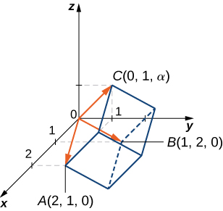

220. Consider points  and  with   and  positive real numbers.

1. Determine the volume of the parallelepiped with adjacent sides   and 
2. Find the volume of the tetrahedron with vertices (*Hint*: The volume of the tetrahedron is  of the volume of the parallelepiped.)
3. Find the distance from the origin to the plane determined by  Sketch the parallelepiped and tetrahedron.

Answer: a.  b.  c. 

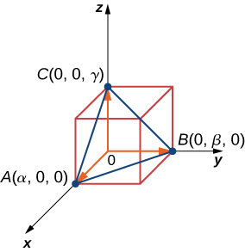

221. Let  bethree-dimensional vectors and  be a real number. Prove the following properties of the cross product.

1. 
2. 
3. 
4. 

Answer: This is a proof; therefore, no answer is provided.

222. Show that vectors   and  satisfy the following properties of the cross product.

1. 
2. 
3. 
4. 

Answer: This is a proof; therefore, no answer is provided.

223. Nonzero vectors  are said to be *linearly dependent* if one of the vectors is a linear combination of the other two. For instance, there exist two nonzero real numbers  and  such that  Otherwise, the vectors are called *linearly independent*. Show that  are coplanar if and only if they are linear dependent.

Answer: This is a proof; therefore, no answer is provided.

224. Consider vectors    and 

1. Show that  are coplanar by using their triple scalar product
2. Show that  are coplanar, using the definition that there exist two nonzero real numbers  and  such that 
3. Show that  are linearly independent—that is, none of the vectors is a linear combination of the other two.

Answer: This is a proof; therefore, no answer is provided.

225. Consider points    and  Are vectors   and  linearly dependent (that is, one of the vectors is a linear combination of the other two)?

Answer: Yes,  where  and 

226. Show that vectors   and  are linearly independent—that is, there exist two nonzero real numbers  and  such that 

Answer: This is a proof; therefore, no answer is provided.

227. Let  and  be two-dimensional vectors. The cross product of vectors  and  is not defined. However, if the vectors are regarded as the three-dimensional vectors  and  respectively, then, in this case, we can define the cross product of  and . In particular, in determinant notation, the cross product of  and  is given by



Use this result to compute  where  is a real number.

Answer: 

228. Consider points   and 

1. Find the area of triangle 
2. Determine the distance from point  to the line passing through 

Answer: a.  b. 

229. Determine a vector of magnitude  perpendicular to the plane passing through the axis and point 

Answer: 

230. Determine a unit vector perpendicular to the plane passing through the axis and point 

Answer: 

231. Consider  and  two three-dimensional vectors. If the magnitude of the cross product vector  is  times larger than the magnitude of vector  show that the magnitude of  is greater than or equal to  where is a natural number.

Answer: This is a proof; therefore, no answer is provided.

232. **[T]** Assume that the magnitudes of two nonzero vectors  and  are known. The function defines the magnitude of the cross product vector  where  is the angle between 

1. Graph the function 
2. Find the absolute minimum and maximum of function  Interpret the results.
3. If  and  find the angle between  if the magnitude of their cross product vector is equal to 

Answer:

a.

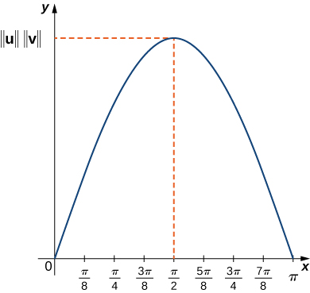

b. ** has two absolute minima at  and  (the vectors have the same or opposite direction). The absolute minimum value of ** is  ** has an absolute maximum value at  (the vectors are orthogonal to each other). The absolute maximum value of ** is  c. 

233. Find all vectors  that satisfy the equation 

Answer:  where  is any real number

234. Solve the equation  where  is a nonzero vector with a magnitude of 

Answer: 

235. **[T]** A mechanic uses a -in. wrench to turn a bolt. The wrench makes a angle with the horizontal. If the mechanic applies a vertical force of  lb on the wrench handle, what is the magnitude of the torque at point  (see the following figure)? Express the answer in foot-pounds rounded to two decimal places.

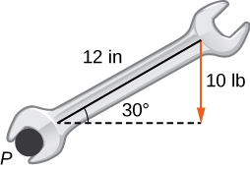

Answer: 8.66 ft-lb

236. **[T]** A boy applies the brakes on a bicycle by applying a downward force of  lb on the pedal when the in. crank makes a  angle with the horizontal (see the following figure). Find the torque at point  Express your answer in foot-pounds rounded to two decimal places.

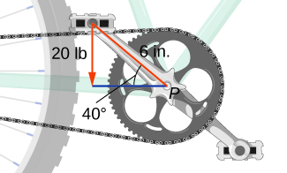

Answer: 7.66 lb-ft

237. **[T]** Find the magnitude of the force that needs to be applied to the end of a cm wrench located on the positive direction of the axis if the force is applied in the direction  and it produces a  N⋅m torque to the bolt located at the origin.

Answer: 250 N

238. **[T]** What is the magnitude of the force required to be applied to the end of a ft wrench at an angle of  to produce a torque of  N⋅m?

Answer: 34.87 N

239. **[T]** The force vector  acting on a proton with an electric charge of  (in coulombs) moving in a magnetic field  where the velocity vector  is given by  (here,  is expressedin meters per second,  is in tesla [T], and  is in newtons [N]). Find the force that acts on a proton that moves in the plane at velocity  (in meters per second) in a magnetic field given by 

Answer: 

240. **[T]** The force vector  acting on a proton with an electric charge of  moving in a magnetic field  where the velocity vector **v** is given by  (here,  is expressedin meters per second,  in  and  in ). If the magnitude of force  acting on a proton is  N and the proton is moving at the speed of 300 m/sec in magnetic field  of magnitude 2.4 T, find the angle between velocity vector  of the proton and magnetic field Express the answer in degrees rounded to the nearest integer.

Answer: 

241. **[T]** Consider  the position vector of a particle at time  where the components of  are expressed in centimeters and time in seconds. Let  be the position vector of the particle after  sec.

1. Determine unit vector  (called the *binormal unit vector*) that has the direction of cross product vector  where  and  are the instantaneous velocity vector and, respectively, the acceleration vector of the particle after  seconds.
2. Use a CAS to visualize vectors   and  as vectors starting at point  along with the path of the particle.

Answer: a. 

b.

­ 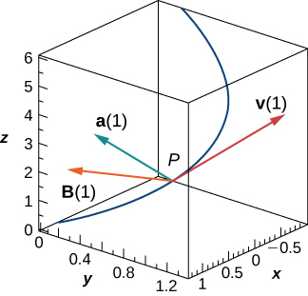

242. A solar panel is mounted on the roof of a house. The panel may be regarded as positioned at the points of coordinates (in meters)    and  (see the following figure).

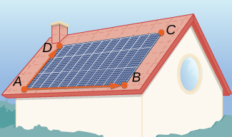

1. Find vector  perpendicular to the surface of the solar panels. Express the answer using standard unit vectors.
2. Assume unit vector  points toward the Sun at a particular time of the day and the flow of solar energy is (in watts per square meter []). Find the predicted amount of electrical power the panel can produce, which is given by the dot product of vectors  and  (expressed in watts).
3. Determine the angle of elevation of the Sun above the solar panel. Express the answer in degrees rounded to the nearest whole number. (*Hint*: The angle between vectors  and  and the angle of elevation are complementary.)

Answer: a.  b.  W; c. 

This file is copyright 2016, Rice University. All Rights Reserved.